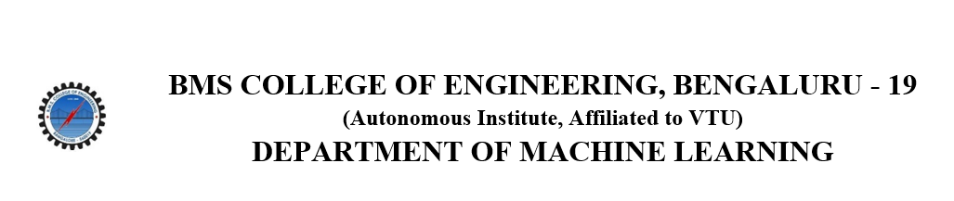
ACTIVITY REPORT
On
InnoVision
Name of the Club: BMSCE ACM STUDENT CHAPTER
Name of the Activity: InnoVision
Objectives: The BMSCE ACM Student Chapter organized a workshop on process and prototype design. To understand the principles of process and prototype design through real-world examples and case studies.
Date, Time Venue of the Activity:
Resource Person | Mr.Nithin Ravi
TOPIC | Process and Prototype design
DATE/DAY | Monday,3rd June,2024
VENUE | ISE Seminar Hall
Name and details of collaborating agency (if it is collaborative/joint activity): IIC BMSCE
Brief summary of the Programme: Our team organized an insightful seminar on process and prototype design, featuring Mr. Nithin Ravi, who is currently pursuing his MBA from the Indian School of Business (ISB) and has substantial experience working in startups. The seminar commenced with formal introductions, setting a professional yet approachable tone for the session. Mr. Ravi, leveraging his entrepreneurial background, began by discussing his experiences and the intricacies involved in startup ventures. This provided a solid foundation for understanding the challenges and opportunities within the startup ecosystem.

The core of the seminar delved into process and prototype design, with a particular focus on real-world applications. Mr. Ravi used case studies of successful startups like Blinkit and Zepto to illustrate key aspects of their process design. These examples helped us understand the practical implementation of theoretical concepts, making the learning experience more relatable and concrete. The discussions highlighted the importance of identifying the target audience and tailoring processes to meet their needs efficiently.
As the seminar progressed, we engaged in a hands-on activity centered around a hypothetical startup idea called "Fit Raho," which focuses on functional training using traditional equipment. Our task was to create a process design to launch this offering and acquire the first 500 paid members for the business's new fitness center in Bangalore. This exercise required us to consider various elements such as target audience, segmentation, targeting, positioning (STP), pricing strategy, promotional strategy, and location preferences. The brainstorming sessions were intense and collaborative, with Mr. Ravi providing invaluable guidance throughout the process.
Overall, the seminar was a fun, engaging, and informative experience. Mr. Nithin Ravi's expertise and approachable demeanor fostered an environment conducive to learning and creativity. The combination of theoretical discussions, practical case studies, and hands-on activities ensured that participants not only grasped the concepts but also learned how to apply them effectively. This seminar has undoubtedly enriched our understanding of process and prototype design, equipping us with the skills needed to navigate the dynamic world of startups
Outcomes: The seminar fostered an engaging and collaborative environment, enhancing participants' problem-solving skills and their ability to devise effective business strategies.
Number of participants:
Number of Faculty | Number of  Non-Teaching Staff | Number of  External Participants | Number of Students
1 | 0 | 0 | 28

Two or three relevant Photographs of the activity:

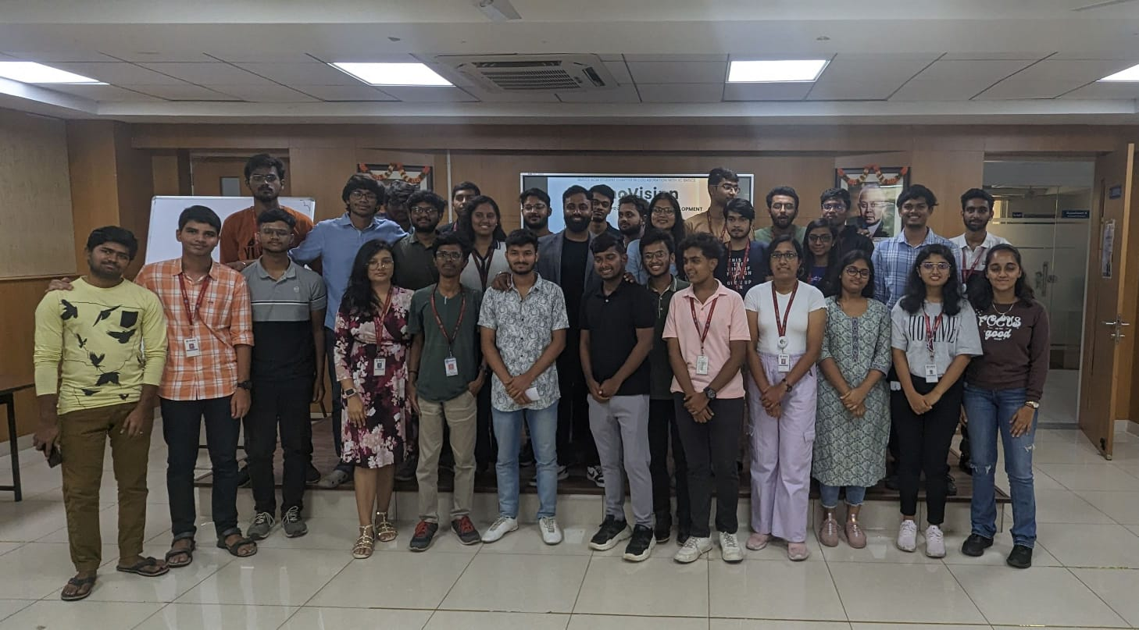

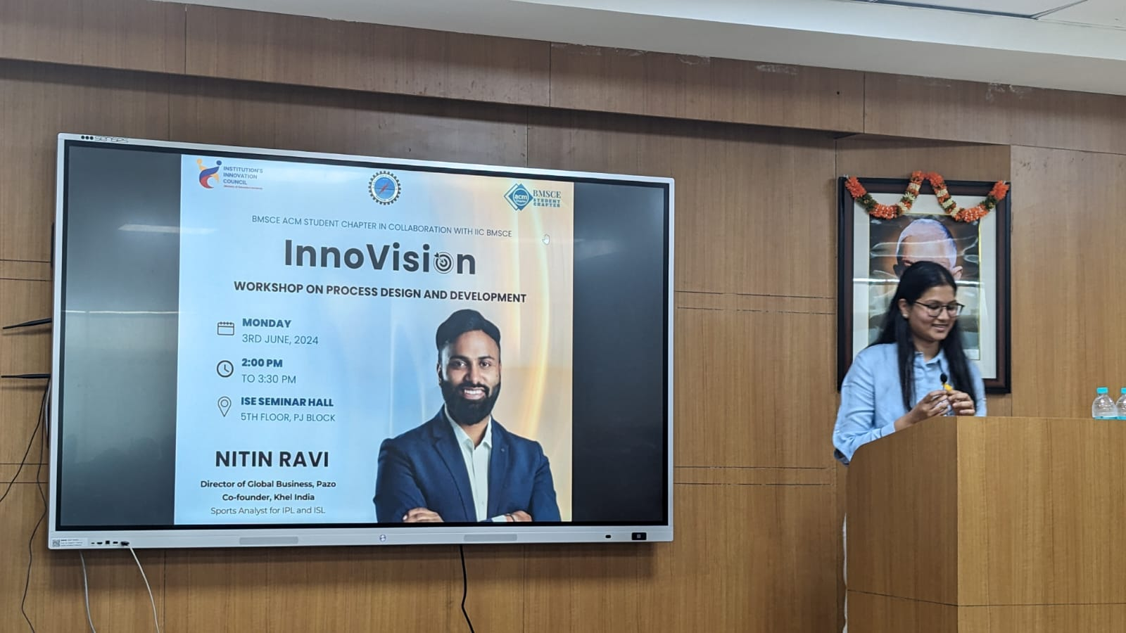

Supporting Documents
a) Attendance sheet
b) Circulars/Brochures
c) Certificates

